Rhinos Asset Holdings | The Rugby Village | Document Number
Rhinos Asset Holdings | The Rugby Village | EMS – 10
Rhinos Asset Holdings | Integrated Management System | Revision No. & Date
Rhinos Asset Holdings | Integrated Management System | 00 – 23 August 2024
Rhinos Asset Holdings | ENVIRONMENTAL METHOD STATEMENT  Solid waste control | Page Number
Rhinos Asset Holdings | ENVIRONMENTAL METHOD STATEMENT  Solid waste control | Page 1 of 3

Date | 23 August 2024
Site Name: | The Rugby Village, Portion 63 & 25 Farm Gustrouw 918,  Mondeor Road, Stellenbosch Farms, City of Cape Town, 7130

Activity: Solid waste management

SCOPE
- Management of solid waste
- Waste hierarchy
- Waste segregation/waste storage requirements.
- Disposal of waste
- Recycling

INTRODUCTION
This method statement outlines the general management controls, and requirements of the generated construction solid waste that need to be implemented and adhered to at all times.

WORKS, MANAGEMENT ACTIONS, CONTROLS

Solid waste management

The Rugby Village shall ensure that all facilities are maintained in a neat and tidy condition and the site shall be kept free of litter. Measures shall be taken to reduce the potential for litter and negligent behavior with regard to the disposal of all refuse/waste.

At all places of work the Contractor shall provide litterbins (Wheelie bins) or containers for later disposal. General solid waste may be temporarily stored on site in a designated area prior to collection and disposal. These temporary waste containment areas shall consist of ready fence panels erected to form a square enclosure to contain the waste, a covered waste skip or enclosed bins to temporarily hold waste and prevent its spread over the site and to other areas. All waste needs to be placed in designated bin areas to avoid the wind blowing the waste on site.

Solid waste will be disposed of at the required landfill site. Waste manifests and IWMP registration documents from the waste removal contractor will be available within the SHEQ office and will be made available upon request by an inspector or ECO.

Waste concrete, if any will be stocked piled until dry, thereafter be relocated to the building rubble pile and will be reused/recycled to create the foundation platforms where needed.

Empty Cement/mortar bags will be disposed of in the allocated wheelie bins within the mixing area (if available), once full, transported to allocated waste skips, waste skips will be covered with netting to avoid further pollution due to inclement weather. Under no circumstances may waste be discharged into the environment or buried.

Waste segregation

Waste materials generated by construction shall be sorted per the categories mentioned below, and/or Recycled:
  - Paper/cardboard
  - Metals

Rhinos Asset Holdings | The Rugby Village | Document Number
Rhinos Asset Holdings | The Rugby Village | EMS – 10
Rhinos Asset Holdings | Integrated Management System | Revision No. & Date
Rhinos Asset Holdings | Integrated Management System | 00 – 23 August 2024
Rhinos Asset Holdings | ENVIRONMENTAL METHOD STATEMENT  Solid waste control | Page Number
Rhinos Asset Holdings | ENVIRONMENTAL METHOD STATEMENT  Solid waste control | Page 2 of 3

  - Glass
  - Plastic
  - Organic waste
  - Whole bricks

Waste management hierarchy

All contractors of Balwin Properties must, as far as reasonably practical will apply the waste management hierarchy below when making decisions on how to manage waste

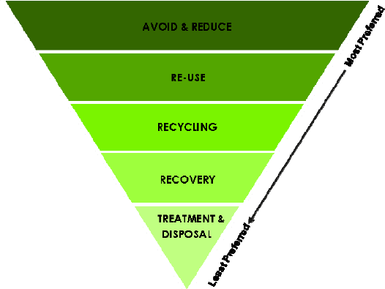

  - Avoid & Reduce – this is the most preferred option. The contractor will endeavour the use of goods and materials with minimum waste components, and also to reduce the quantity and toxicity of waste generated during the development phase.
  - Reuse – the contractor will, as far as possible, endeavour to reuse materials and items rather than disposing of them.
  - Recycle – whatever can be recycled should be recycled by the contractor.
  - Recovery – this step involves reclaiming components or materials, or using the waste as a fuel.
  - Treatment & Disposal – as a last resort, waste enters the lowest level of the hierarchy to be treated and/or disposed of, depending on the safest manner for its final disposal.

The following will be relevant contact details:
Name and Surname | Representing – Position | Contract details
Mynhardt Enslin | Rhinos Rugby Academy- Project Director/Site Manager | 083 603 0770
Neels Van Koeler | Boland Grondwerk – Civil Contractor | 082 940 1749
Calie Vermeulen | Boland Grondwerk – Site Foreman | 083 607 8589
Chris Oosthuizen | Safe Working Practice – SHEQ Consultant | 082 888 6456
Monique Norman | Health & Safety Manager | 072 261 8203
Klye Enslin | Pepper Pod - Construction Manager | 083 759 5816
Roelof Rabe | Roelof Rabe – Consulting Architect | 021 914 1690
Divan Opperman | Guillaume Nel Environmental Consultants | 076 453 8829

Rhinos Asset Holdings | The Rugby Village | Document Number
Rhinos Asset Holdings | The Rugby Village | EMS – 10
Rhinos Asset Holdings | Integrated Management System | Revision No. & Date
Rhinos Asset Holdings | Integrated Management System | 00 – 23 August 2024
Rhinos Asset Holdings | ENVIRONMENTAL METHOD STATEMENT  Solid waste control | Page Number
Rhinos Asset Holdings | ENVIRONMENTAL METHOD STATEMENT  Solid waste control | Page 3 of 3

DECLARATIONS FOR ENVIRONMENTAL METHOD STATEMENT
SITE MANAGER  The works described in this Method Statement, if carried out according to the methodology described, is satisfactory to prevent or control environmental harm and is thus approved:  SM Name Approval Date Signature | CONTRACTOR  I understand the contents of this Method Statement and the scope of the works required of me. I further understand that this Method Statement may be amended on application to and with approval by the Site Manager, and that the SHE Officer, Construction Manager and ECO will audit my compliance with the contents of this Method Statement:  Contractor ___________ _____  Acceptance Date ______________ __  Signature __________________
ENVIRONMENTAL CONTROL OFFICER (ECO)  The works described in this Method Statement, if carried out according to the methodology described, is satisfactory to prevent or control environmental harm and is thus approved:  Name  Approval Date Signature | COMMENTS:

